|  |  |
| --- | --- |
|  | **YEAR 12 MATHEMATICS SPECIALIST**  **SEMESTER ONE 2017**  **QUESTIONS OF REVIEW 2: Functions** |

Name: _______________________

Wednesday 29th March Time: 40 minutes Mark /35

Calculator free.

1. **[3 & 3 = 6 marks]**

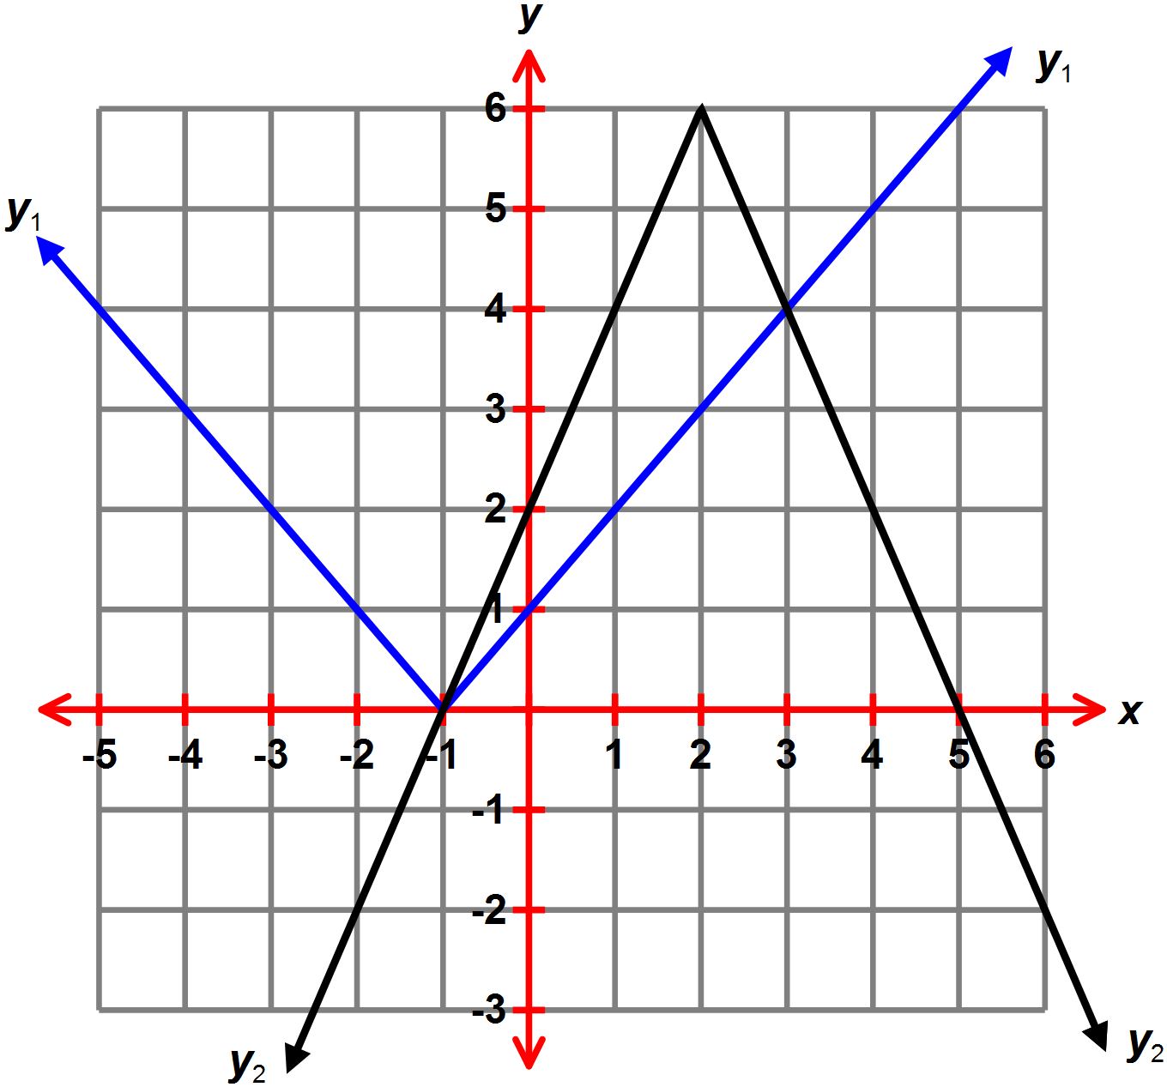The graphs of *y*1 and *y*2 are shown on axes to the right.

1. Use the graph to solve the following equations.
2. 
3. 
4. 
5. State the equation for the graph of
6. *y*1 **(ii)** *y*2
7. **[5 marks]**

Calculate where  intersects .

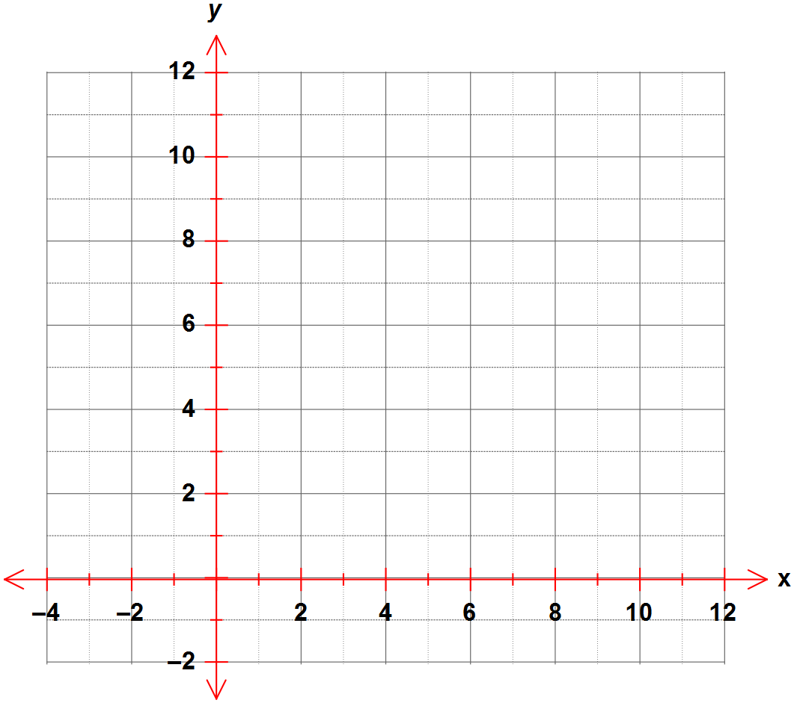Represent your solution on the axes provided.

1. **[5 marks]**

 and 

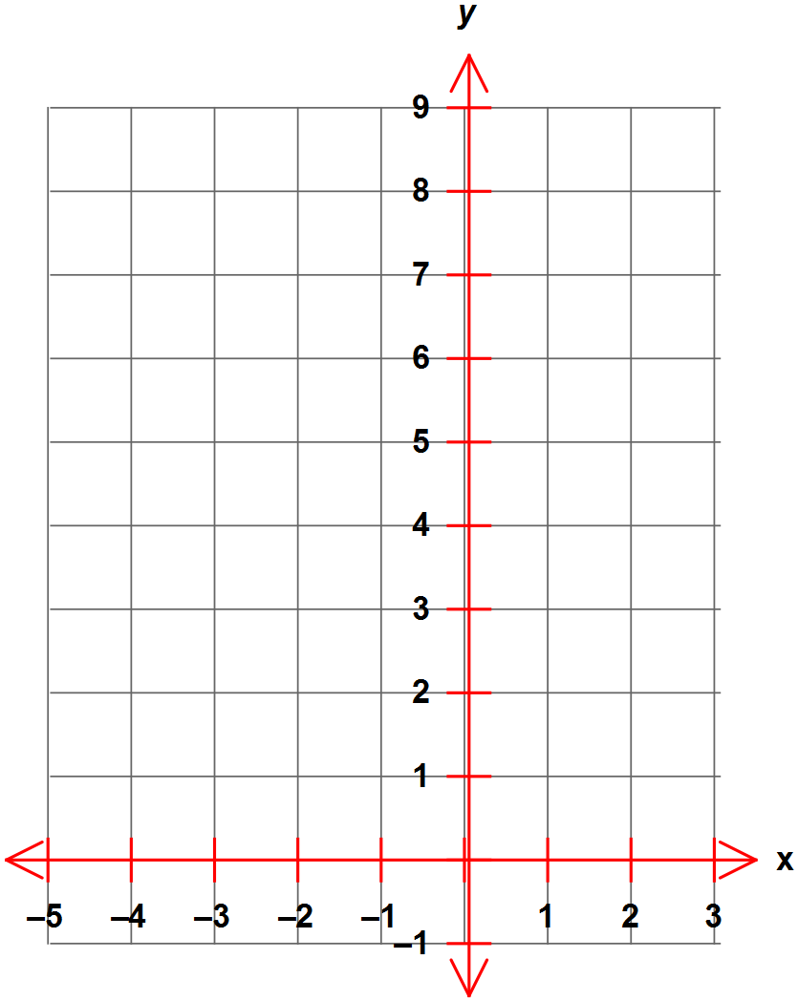Determine a piecewise defined expression for the sum  and sketch  on these axes.

1. **[2, 2 & 6 = 10 marks]**

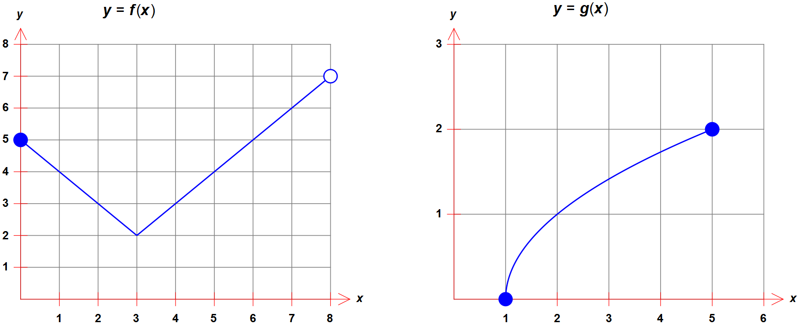The graphs of  and  are shown.

* 1. Does  possess an inverse function? Explain
  2. Find

**(i)**  **(ii)** 

* 1. State

**(i)** the domain of *g* **(ii)** the range of *f*

**(iii)** the maximal range of 

**(iv)** the maximal domain of 

1. **[2, 2, 2, 1 & 2 = 9 marks]**

The axes to the right show the graph of .

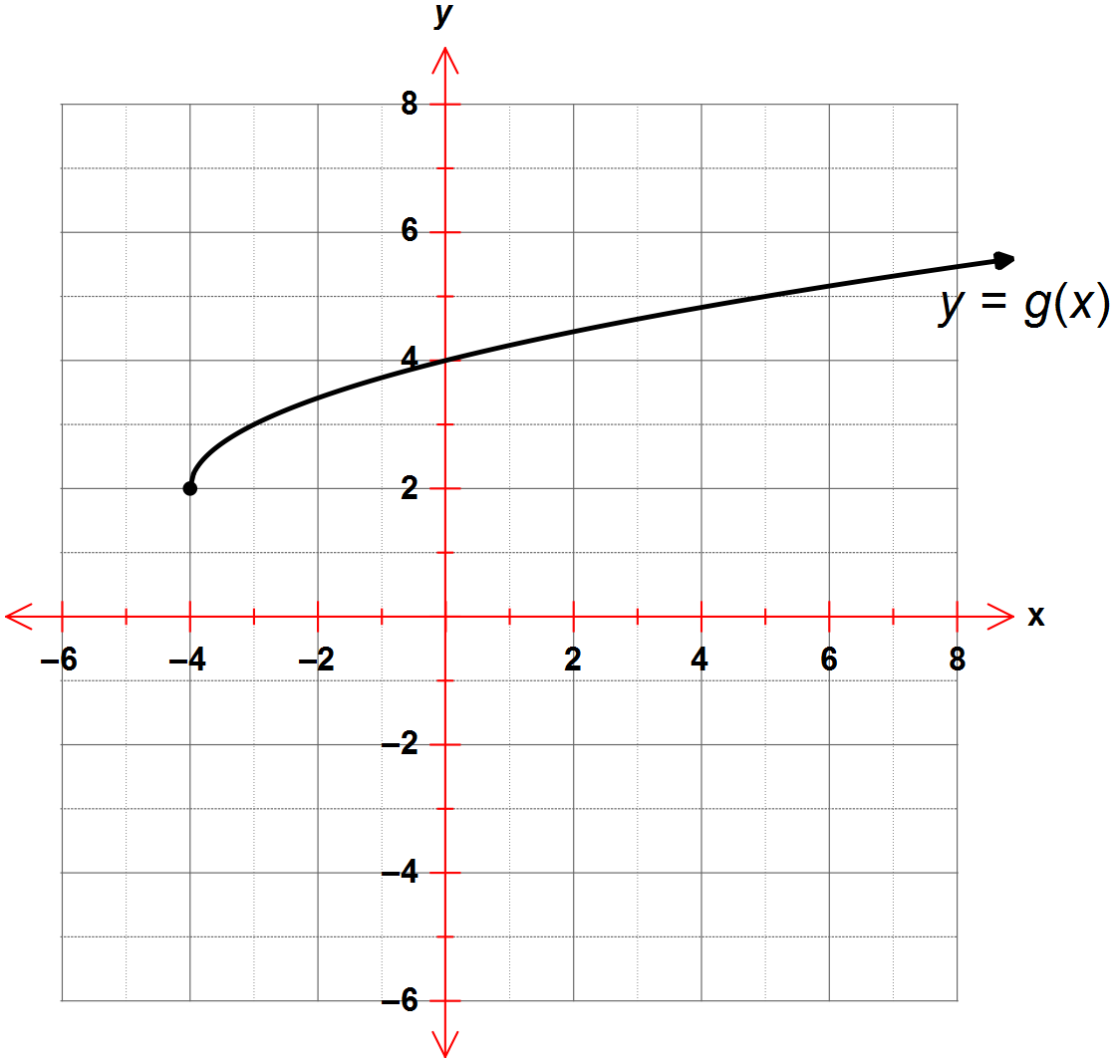

1. Find the value of  if .
2. **(i)** State the range of 

**(ii)** State the domain of 

1. Find the defining rule for  in simplest form.
2. Is  one-to-one?
3. On the axes above, add a sketch of the graph of  showing the coordinates of all relevant features clearly.